Princess Sumaya University for Technology
King Abdullah II Faculty of Engineering
Engineering Department



embedded system final project
Autonomous mobile robots

Authors: |  | Supervisor:
Sally Burjak  Lama Al Alami  Ibrahim  Al-Shiltawi | 20220396  20220395  20220151 | Dr. Esam Qaralleh
January 11, 2025
Abstract
This project presents the design and implementation of a 2WD autonomous robot car using the PIC16F877A microcontroller. The robot is designed to navigate a track consisting of six different zones. These zones include a start zone, where the car waits for three seconds after a button is pressed, followed by a line-following zone in which the robot follows a black line. The robot then passes through a tunnel zone with reduced lighting, where the buzzer is activated and the car must exit within a limited time. After that, the robot enters an obstacle detection zone, where it detects obstacles and finds a safe path to move forward. Finally, the robot reaches the parking zone, where it stops correctly to complete the task.
The system was programmed using mikroC, and multiple sensors were used to guide the robot’s movement, including IR sensors, an LDR, and an ultrasonic sensor. An H-bridge motor driver was used to control the direction and speed of the motors, while a buck regulator was used to provide a stable 5 V power supply. All sensor inputs and system outputs are controlled by the PIC microcontroller.
During the project, several challenges were faced, including overheating of the buck regulator and instability of IR sensors, which were addressed through hardware adjustments and software tuning.

Table of Contents
Introduction 2
Objectives 2
Design 3
Equipment Used: 3
Mechinical Design: 3
Electrical design: 4
Problems and recommendations 6
Conclusions 7

Introduction

In this project, a 2WD smart robot car was designed and implemented using PIC16F877A microcontroller. Different sensors were used to help the robot move autonomously, including two infrared (IR) sensors for line following, an LDR for light detection, Servo motor to raise the flag, and an ultrasonic sensor alongside two infrared (IR) sensors for obstacle and wall detection and finally another 2 infrarad (Iri0 sensors for parking purposes. Motor movement was controlled using an H-bridge powered by 12V power source, and a buck regulator was used to reduce the input voltage and provide stable power to the system.
The robot car is designed to move autonomously through six different zones. The car starts in the start zone, where the car remains still until a push button is pressed. After the button is pressed, the car waits for three seconds and then begins movement. The car then enters the line-following zone, where it must follow a black line on the track. After that, the robot passes through a tunnel zone with reduced lighting. Inside the tunnel, a buzzer is activated to indicate the low-light condition. Once the tunnel is exited, the car enters a path navigation zone without guiding lines, where it must detect obstacles and find a safe path.Following this section, the black line appears again and the car encounters a bump, which it must climb smoothly. Finally, the robot reaches a fully black parking zone, where it slows down, parks correctly, and raises a flag and turn off the LED to indicate successful completion of the task.

Objectives
- Design an autonomous robot car based on the pic 16F877A
- Develop the embedded software using mikroC to control the sensors, actuators and robot behavior.
- Implement a robot car that can successfully pass all six zones of the challenge track.

Design

Equipment Used:
- PIC16F877A – Used as the main controller for processing sensor inputs and controlling all system outputs.
- IR Sensors – Used to detect the black line for line-following operation and to detect the walls.
- LDR (Light Dependent Resistor) – Used to detect low-light conditions inside the tunnel.
- Ultrasonic Sensor – Used for obstacle detection and distance measurement.
- H-Bridge Motor Driver – Used to control the direction and speed of the motors.
- Buck Regulator – Used to reduce and stabilize the input voltage supplied to the system.
- DC Motors – Used to drive the movement of the robot car.
- Resistors – Used for current limiting and signal conditioning.
- Capacitors – Used for filtering and voltage stabilization.
- Crystal Oscillator – Used to provide the clock signal for the microcontroller.
- Wires – Used for electrical connections between components.
- Buzzer – Used as an audio indicator during tunnel operation and parking.
- Battery – Used as the main power supply for the robot car.
- LEDs – Used to indicate system status.
- Two Push Button – Used to start the robot operation and for the MCLR.
- Switch – for the power

Mechinical Design:
All equipment is placed on a 2WD chassis, with a power switch placed at the center of the car. Two DC motors are installed at the bottom of the chassis and connected directly to the wheels, while a free wheel is placed at the middle.Two IR sensors are placed at the bottom of the car to detect the black line,they are approximately 5 cm apart and very close to the ground for accurate detection. In addition, two IR sensors are placed one on each side of the car to detect the walls during path navigation and two IRs at the back for the parking .An ultrasonic sensor is placed at the front of the car for obstacle detection. The motors are controlled through an H-bridge motor driver, while all sensors are powered using a buck regulator that provides a stable 5 V supply.
To ensure smooth movement over the bump, the weight of the car was balanced as much as possible. For this reason, the battery, which is the heaviest component, was placed at the front of the chassis.

Electrical design:
All sensor inputs and system outputs are controlled by the PIC16F877A. All sensors are connected as inputs to the PIC. The IR sensors are connected to PORTs B and D, since they are standard digital inputs . The LDR sensor is connected to RA0, as it is an analog input pin used to detect light intensity.
The enable pins of the H-bridge are connected to RC1 and RC2, which support hardware PWM, allowing control of the motor speed.The LED is connected as an output to indicate that the car has started operating. Similarly, the buzzer is connected as an output to indicate the low-light condition inside the tunnel.
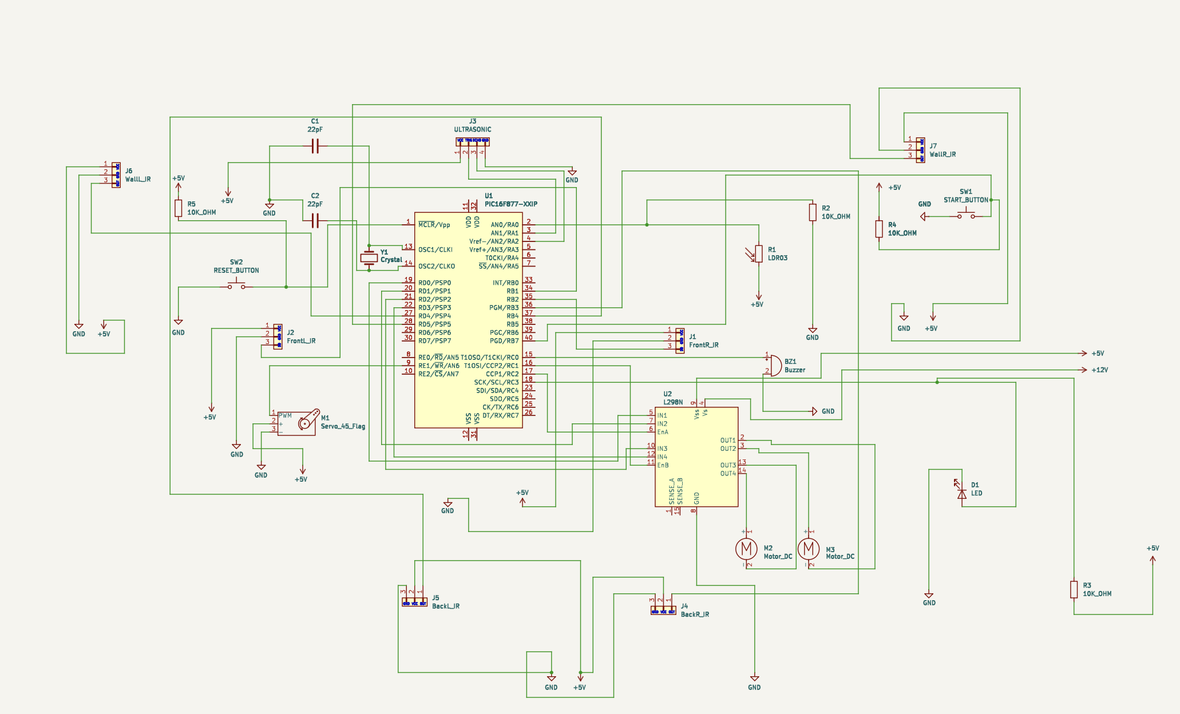

Figure1:schema
Software design:
The software was developed using mikroC for the PIC16F877A. The track is divided into six different zones, and the program is designed to allow the robot car to detect and pass through each zone automatically. After defining all input and output pins, the program waits for the push button to be pressed, then enters a while loop that allows the system to run continuously.Inside the loop, the program first checks for the parking zone. If all IR sensors detect a black surface, the car moves forward and then turns right while the buzzer beeps every one second. After completing the parking process, the car raises a flag, turns off the LED, stops all motors, and exits the loop.Next, the program checks for the T-intersection, if both the front IR detect black serface stop turn left move forword.After the programe has checked that it is not T-intersection it goes to the LDR sensor. If the light level is below the threshold value (450 ), the buzzer is activated ,Ultrasonic is turned off and the motor speed is increased to allow the car to pass through the tunnel smoothly.
The program then performs line-following control. When the black line is centered, IR sensors detect white, and the car moves forward. If the right IR sensor detects black, the car turns left, and if the left IR sensor detects black, the car turns right. This logic is used to keep the black line centered between the sensors during movement.Finally, the program checks the ultrasonic sensor along with the side IR sensors for obstacle detection. If the measured distance is less than 20 cm, the car adjusts its direction based on the side IR sensor readings to avoid the obstacle and continue moving forward.

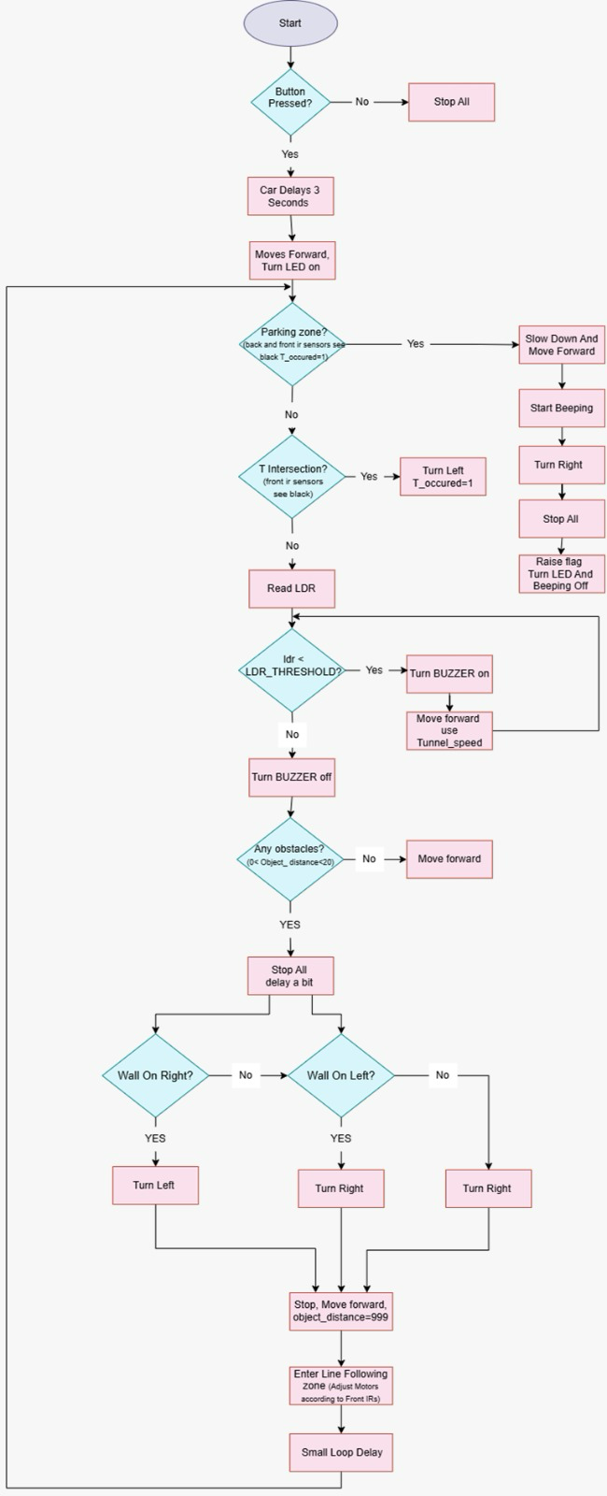

Figure 2: flowchart

Figure 2: flow chart

Problems and recommendations
During the design of the robot car, several challenges were faced. The first major issue was overheating of the buck regulator, which became very hot during operation. Multiple checks were performed to ensure there was no short circuit, and all connections were reviewed more than once. The regulator was replaced several times, and a different car was built again ; however, there was not enough time to complete the programming for that setup. Another challenge was related to the IR sensor configuration. Initially, a 5-channel IR sensor was used for line detection, as it is commonly recommended for faster performance. However, in our case, the car became unstable due to excessive and conflicting sensor readings. To improve stability, the design was changed to use two IR sensors at the bottom of the car. This configuration provided better and more reliable line-following, although the car was still not perfectly stable in all situations. Another problem was that one wheel was faster than the other, causing the car to drift to the right. This was fixed by adjusting the motor speeds in the software design so both motors run at the same speed.
Recommendations:
- Use a higher-current rated regulater.
- While designing the car, connect the components step by step. Only connect the sensors that are being programmed at that time, as this simplifies debugging and makes the process easier.
- Keep the IR sensors close to the ground to achieve more accurate line detection.
- Organize the code by using functions and use flags to control transitions between the zones
- Use small delays.
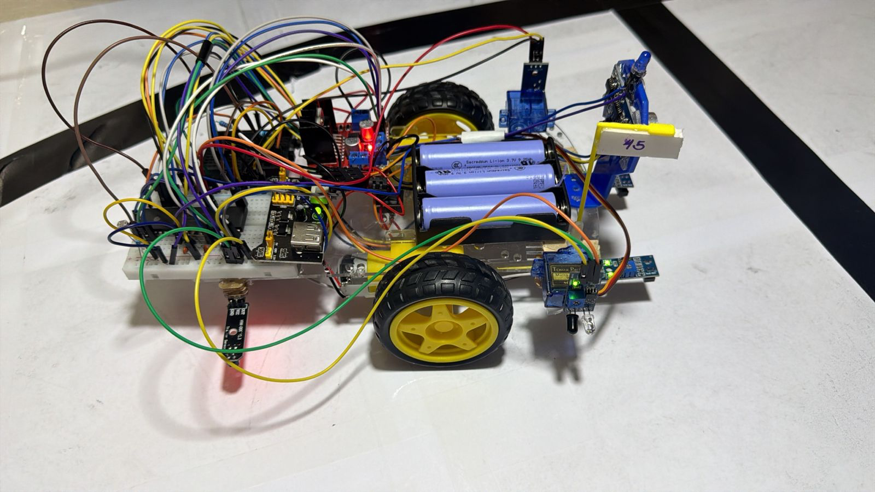

Figure 3: final Design

Conclusions
The 2WD robot car was successfully designed and implemented based on the PIC16F877A. The robot was able to pass through the six required zones, including line following, tunnel navigation under low-light conditions, obstacle avoidance, bump climbing, and final parking.
During the implementation of the project, several challenges were faced; however, these issues were successfully solved. The ultrasonic sensor sometimes did not work perfectly, although the car performed well on the designed track. If the robot were placed on a different track with a different sequence, its performance would not be as reliable since many functions were preprogrammed for this specific environment.
Overall, the project was challenging and difficult. Despite some remaining mistakes and limitations, the project still has room for improvement and future development.

